FY2017 Neighborhood Arts and Festivals
Grant Recipient Handbook

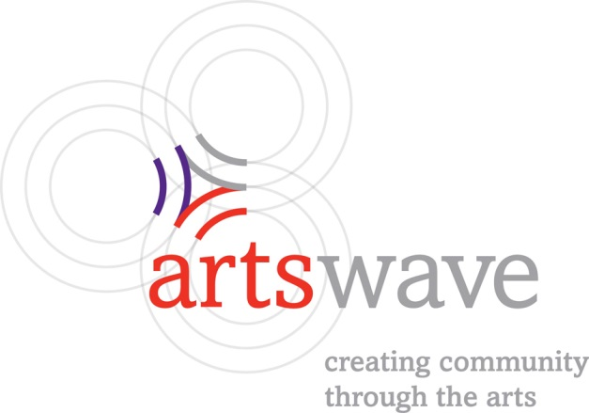

Neighborhood Arts and Festivals Grant Recipient Handbook
The purpose of this handbook is to outline the grantee expectations and requirements for the
Neighborhood Arts and Festivals grant program for FY2017. By accepting funding through the Neighborhood Arts and Festivals Grant Program, an organization agrees to adhere to the grantee guidelines outlined in this document.

Grant Recognition Guidelines
Neighborhood Arts and Festivals support is provided by contributors to the annual ArtsWave campaign. The ArtsWave Community Campaign receives contributions from generous individual, business and
foundation donors. To reinforce the importance of their gifts, we need them to see and understand the
connection between their contribution to ArtsWave and the amazing work of your organization. Public
recognition of this grant, and thereby of all donors to ArtsWave, is important to sustain and encourage
future contributions to this remarkable community resource.
We ask recipient organizations to credit ArtsWave as space is available in all promotional materials for the funded event including, but not limited to: calendars, postcard announcements, invitations, news releases, radio and television spots, social media posts, e-communications vehicles, and street banners.

Name and Brandmark Usage

Always use the full name: ArtsWave, with a capital “A” for Arts and a capital “W” for Wave and no space
between Arts and Wave. ArtsWave brandmarks are available for download at
www.TheArtsWave.org/about/media-resources.

When the logo will be on printed materials and less than 2 inches in width, use the brandmark without
rings or tagline. The logo should never appear at a size less than ¾ inch. The tagline proportion and
placement should never be altered.

In all cases, please make sure the brandmark is clearly legible and recognizable.

Print Recognition

Newspaper/Magazine Advertising
Any advertising for the funded event, regardless of size or length, should credit ArtsWave.

News Releases
News releases about the funded event must credit ArtsWave support. Example: “XYZ is supported by the generosity of more than 40,000 contributors to the ArtsWave Community Campaign.”

Event Signage
Wall text must include ArtsWave. If there is no wall text, grant recipients may place a sign near the entrance crediting ArtsWave as follows: “Supported by the generosity of community contributions to the ArtsWave Campaign.”

Electronic Recognition

Broadcast Advertising
Include ArtsWave in all radio and television spots promoting the funded event. Radio spots should give verbal credit to ArtsWave (copy: “Funding support comes from ArtsWave”) and television spots should include the ArtsWave logo.

Digital Advertising
Logo credit should be provided in all digital advertising for the funded event. Acknowledgement of ArtsWave support should be proportional to its share of support compared to other sources.

Social Media
Tag @ArtsWave on posts and shares about the funded event and, when appropriate, use hashtags such as #CincyArts and #BlueprintNeighborhoods. This will allow ArtsWave to find and share posts, thereby amplifying the reach and message.

Oral Recognition

In cases when there are no printed materials, grant recipients can provide oral credit before the event funded through this grant. As in press releases, oral credit should explicitly thank the community: “XYZ is supported by the thousands of people who give generously to the ArtsWave Community Campaign.” If an announcement is not possible, grant recipients may place a sign at the entrance of the event.

Collaborative Marketing

One of ArtsWave’s goals is to communicate excitement about the event funded through this grant. Grant recipients should post all event information on CincyArtsGuide.com. For assistance with adding your event to Cincy Arts Guide, contact Leyla Shokoohe, Communications Coordinator, at leyla.shokoohe@theartswave.org.

Grant Acceptance

Grant recipients are asked to submit a FY2017 Neighborhood Arts and Festivals Grant Acceptance via the grantee portal. In addition to some administrative paperwork, the grant acceptance includes an Evaluation Plan for the funded event. The Evaluation Plan includes three objectives for the event with projected results. The grant acceptance form can be located here:

https://www.grantrequest.com/SID_2232/?SA=AM.

You should log into the grantee portal with the same email and password you used to submit your grant application. The grant acceptance is due on or before February 28, 2017. (NOTE: If ArtsWave does not receive the grant acceptance by the deadline, it will be assumed that the grant award has been declined.)

Grant Payment

A single grant payment will be issued by check or by EFT (if authorization has been provided) upon receipt of the completed FY2017 Neighborhood Arts and Festivals Grant Acceptance Form via the grantee portal. Grant payments are issued on the 5th and the 20th of the month.

Post-Award Changes to Event

Grantees must notify ArtsWave of any substantial changes to the event as soon as possible. Changes will be evaluated on a case-by-case basis but may result in a partial or full refund of the grant award.

Final Report

Grant recipients must submit a Neighborhood Arts & Festivals Grant Final Report via the grantee portal within 30 days of the completion of the event. The final report includes a financial report, an evaluation report with the actual results achieved for each of the three objectives outlined in the evaluation plan, and lessons learned during program implementation that might be valuable to the broader sector. Failure to submit your final report in a timely fashion may result in ineligibility for future funding from ArtsWave.

Photographs

ArtsWave publicizes its grants and generates excitement about the impact of the arts through media outlets, via social media platforms, through our e-newsletters and on our website. As a part of the final report, we ask grant recipients to submit at least three photographs that showcase the funded event. ArtsWave will assume that we have permission to use and share these photographs and any attributions (if provided), unless expressly told otherwise.

Proof of Grant Recognition

PDFs or JPGs of programs and other materials should also be submitted along with your final report. We encourage you to send us press releases, copies of publications or media coverage that mention your grant.

Additional Information

If you have additional questions regarding this document, your award, or the decision-making process used by the committee to determine your award, please feel free to contact Alison Taylor, Impact Specialist – Community Development, at 513.632.0126 or alison.taylor@theartswave.org.

