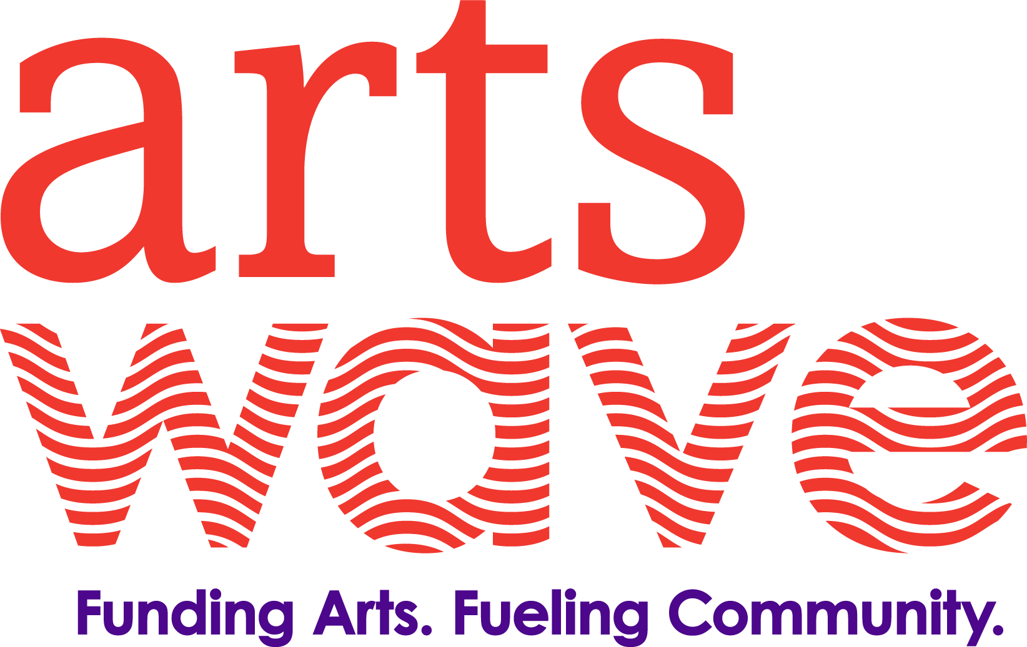

Diversity, Equity, Inclusion & Access Plan Toolkit
A Comprehensive Set of Resources from the Annie Casey Foundation
https://www.aecf.org/resources/race-equity-and-inclusion-action-guide/
A Human Resources Perspective
https://breezy.hr/blog/inclusion-in-the-workplace-10-simple-rules
American Alliance of Museums’ Diversity, Equity, Accessibility, and Inclusion Working Group
https://www.aam-us.org/wp-content/uploads/2018/04/AAM-DEAI-Working-Group-Full-Report-2018.pdf
Americans for the Arts Cultural Equity Statement
https://www.americansforthearts.org/about-americans-for-the-arts/our-statement-on-cultural-equity
Americans for the Arts Cultural Equity Tools & Templates
https://www.americansforthearts.org/about-americans-for-the-arts/cultural-equity/tools-and-templates
An Organizational Culture Perspective
https://www.chieflearningofficer.com/2020/08/21/the-critical-first-step-to-building-strong-organizational-dei/?utm_campaign=CIR_CLO_Daily%20Digest_2020&utm_medium=email&_hsmi=93812678&_hsenc=p2ANqtz--AoGcgQzkvG_mQIY8HTT0M3xdOophEwMHfZOYaTGjPmiimFpZNG2Hrrr_vQoy3oPWQL7Pp_JNOXOqS6n8k8pgRao6Lvg&utm_content=93812678&utm_source=hs_email
Building a Cultural Equity Plan
https://www.policylink.org/our-work/community/arts-culture/plan
Calibrated Lens - Exploring Differences, Reducing Harm, Evolving Strategies
https://7eb00da2-96cb-4226-b3dc-6d4de58aba81.filesusr.com/ugd/1620bc_75032410cd454ef29d82250de37cf9ee.pdf
Cleveland Museum of Art - Diversity, Equity and Inclusion Plan
https://www.clevelandart.org/diversity-equity-and-inclusion-plan
Dance/NYC – Values of Justice, Equity & Inclusion
https://www.dance.nyc/equity/values
Greater Cincinnati Foundation – Racial Equity Matters
https://www.gcfdn.org/REM
Harvard Business Review - 10 Commitments Companies Must Make to Advance Racial Justice
https://hbr-org.cdn.ampproject.org/c/s/hbr.org/amp/2020/06/the-10-commitments-companies-must-make-to-advance-racial-justice
League of American Orchestras – The Equity, Diversity, and Inclusion Resources Center
https://americanorchestras.org/board-members-volunteers/the-governance-center/diversity-and-inclusion-resource-center.html
National Underground Railroad Freedom Center – Open Your Mind Understanding Implicit Bias
https://freedomcenter.org/visit/permanent-exhibits/open-your-mind-understanding-implicit-bias/
OF/BY/FOR ALL
https://www.ofbyforall.org/
OhioDance – Resources on Anti-Racism and Equity
https://ohiodance.org/wp-content/uploads/2020/06/Resources-on-Anti-Racism-and-Equity-compiled-by-OhioDance.pdf
Stanford Social Innovation Review on Defining Equity
https://ssir.org/articles/entry/what_the_heck_does_equity_mean
Theatre Communications Group Mission and Values
https://circle.tcg.org/about/mission-and-values?ssopc=1
The Business Case for DEI from McKinsey
https://www.mckinsey.com/featured-insights/diversity-and-inclusion/diversity-wins-how-inclusion-matters
YWCA Cincinnati – Toward Equity: Moving Beyond Diversity & Inclusion
https://www.ywcacincinnati.org/our-programs/trainings/toward-equity/
We See You W.A.T. (White American Theater)
https://www.weseeyouwat.com/
White Ally Toolkit
https://www.whiteallytoolkit.com/news/2020/6/3/message-to-white-allies-from-a-black-anti-racism-expert-youre-doing-it-wrong

